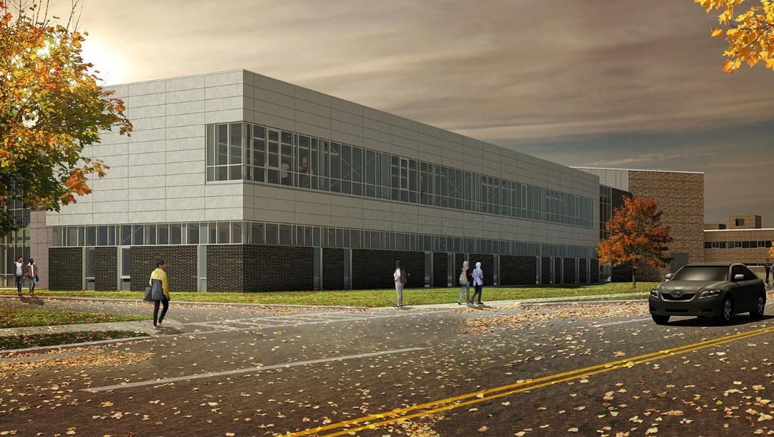

MINIMUM CAPACITY :-

The Minumum intake capacity

of students is between 300-420

children

LIBRARY :-

The Libarary is Available.

CANTEEN:-

The Canteen Facility is Available.

BOARDING :-

No availablility of boarding.

SPORTS :-

There are different categories

sports available.

Girls Volleyball

Boys Volleyball

Football

|  |  |  |
| --- | --- | --- |
| GIFFEN MEMORIAL SCHOOL  ALBANY - SCHOOL |  |  |
|  |  |  |
| School Detail :- Giffen Memorial Elementary School is an exciting learning place where young people develop their natural gifts and abilities as they gain confidence in their potential. Students grow to become well-adjusted, independent thinkers as they explore their intelligences  Giffen Memorial Elementary School is an exciting learning place where young people develop their natural gifts and abilities as they gain confidence in their potential.  Students grow to become well-adjusted, independent thinkers as they explore their intelligences; they realize the satisfaction of productive teamwork as they collaborate with others from a variety of racial, ethnic and economic backgrounds.  Stimulating activity integrates themes and basic content, resulting in higher scholastic achievement for all. |  |
|

